**A TALE IN EVERY FRAME: THE ART OF CRAFTING IMAGE CAPTIONS**

CSA1321- THEORY OF COMPUTATIONS FOR POLYNOMIAL

**Submitted to**

SAVEETHA INSTITUTE OF MEDICAL AND TECHNICAL SCIENCES

**In partial fulfilment of the award of the degree of**

BACHELOR OF ENGINEERING IN COMPUTERSCIENCE

**By**

C.ASWINI CHOUDARI [192211442]

U. SUJALA REDDY [192211737]

A. SUJITHA REDDY [192211824]

**Supervisor**

Dr. R. LATHA



**SAVEETHA SCHOOL OF ENGINEERING**

**SIMATS CHENNAI- 602105**

**MARCH-2024**

**CONTENTS**

|  |  |  |
| --- | --- | --- |
| **S. N0** | **TITLE** | **PAGE NO** |
| **1** | **ABSTRACT** | **3** |
| **2** | **INTRODUCTION** | **3-4** |
| **3** | **MATERIALS AND METHODS** | **5** |
| **4** | **RESULTS AND DISCUSSIONS** | **6** |
| **5** | **CONCLUSIONS** | **7** |
| **6** | **REFERENCES** | **7-8** |

**ABSTRACT:**

**AIM:** The goal of image caption generators is to automatically create insightful captions for images, improving readability and accessibility. They bridge the gap between textual descriptions and visual content using natural language processing techniques and sophisticated neural network architectures. These systems optimize information transfer and enable efficient communication across various applications and platforms by producing precise and succinct captions. Their main objective is to improve the user experience by meaningfully and easily communicating the essence of visual content. **METHODOLOGY:** Preprocessing data to extract features from text and images is necessary for efficient image caption generation. During captioning, the model architecture—which frequently includes attention mechanisms—is made to concentrate on pertinent image regions. It is important to train on paired datasets and use optimization strategies such as teacher forcing. Evaluation metrics that measure caption quality and coherence include the BLEU score. The objective is to generate succinct, richly contextualized descriptions while maximizing the transfer of information. **RESULT AND DISCUSSION:** Metrics like the BLEU score and human review confirm how robustly the image caption generator generates descriptive captions. It ensures accurate interpretations by effectively bridging the semantic gap between textual descriptions and visual content. The effects of model architectures, training methodologies, and assessment metrics on performance are the main topics of discussion. Future improvements might focus on managing intricate scenes and a variety of picture formats to maximize data transfer and user experience throughout applications. All things considered, the generator appears to have potential for improving visual content accessibility and comprehension. **CONCLUSION:** In conclusion, automatic captioning of images by the image caption generator greatly enhances accessibility and comprehension of visual content. Thorough assessment validates its efficiency in bridging the visual and textual modalities, indicating improved user experience in a variety of applications. Subsequent developments are intended to enhance the generator's functionality even more, guaranteeing best-in-class data transfer and ongoing innovation in the industry.

**KEYWORDS:** Image Captioning, Computer Vision, Natural Language Processing, Neural Networks, Semantic Gap, Automatic Caption Generation.

**INTRODUCTION:**

In today’s world, the overwhelming number of images we see on a daily basis in today's visually-driven world poses a special challenge for machines, as they are not endowed with the same sense of perception and interpretation that humans have. By bridging the gap between natural language processing and visual understanding, Image Caption Generator models represent a revolutionary development in artificial intelligence. Using advanced architectures like the encoder-decoder framework, these models allow machines to produce comprehensible and contextually relevant captions for images, effectively giving them the ability to comprehend visual information.

Convolutional neural networks (CNNs) and long short-term memory (LSTM) networks, the fundamental building blocks of Image Caption Generator models, have different but complementary functions during the caption generation process. CNNs are particularly good at removing complex visual elements from photos, picking up on subtleties and details that add to our comprehension of the scene. In the meantime, LSTM networks are highly skilled at arranging and sequencing these features into captions that are coherent and relevant while also adhering to grammar rules. The practical applications of image captioning technology are numerous and extensive, despite their technical complexity. In the area of accessibility, for example, these models enable people who are visually impaired by giving them access to real-time audio descriptions of their environment that are recorded via camera feeds. This increases their autonomy and independence while also promoting greater inclusion and participation in everyday activities. Additionally, the way we interact with visual content online is revolutionized by social media platforms' incorporation of image captioning technology. Deeper connections and interactions within online communities are fostered by automatically generated captions for images shared on these platforms, which make it easy for users to understand the context and content of each image.  
  
Image captioning is a potent tool in educational settings that helps with learning and comprehension in a variety of subject areas. These models enhance the learning process and support knowledge retention, whether they are used to help language learners associate words with visual stimuli or to help students understand complex scientific concepts through annotated diagrams. Furthermore, image captioning has an impact on industries like healthcare, where it helps medical professionals diagnose and analyze medical images more accurately and quickly. These models improve diagnostic capabilities and help patients receive better care by offering thorough descriptions of anomalies or abnormalities found in images. To sum up, image captioning technology signifies a paradigm shift in the way we engage with and interpret visual content. Its capacity to close the gap between natural language processing and visual understanding opens up a plethora of opportunities in a variety of fields, including education, healthcare, accessibility, and more. With further developments in this area, image captioning has the potential to completely transform our digital world and improve human-machine interactions.

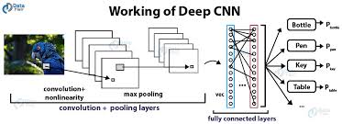

**FIGURE :1**

**METHODOLOGY:**

The process of creating an image caption generator includes a few crucial steps. First, a sizable dataset of matched photos with captions is gathered and prepared. Tokenizing captions, resizing photos, and creating vocabulary indices are common preprocessing tasks. After preparing the data, a suitable model architecture is chosen. This often involves using Recurrent Neural Networks (RNNs) such as Long Short-Term Memory (LSTM) or Gated Recurrent Unit (GRU) for caption generation and Convolutional Neural Networks (CNNs) for extracting image features. The paired dataset is then used to train the model. First, images are fed into CNN to extract features, and then the CNN feeds these features into the RNN to generate captions. By modifying its parameters during training, the model learns to minimize a loss function and produce captions that closely resemble the ground truth captions. The quality, relevance, and fluency of the generated captions in comparison to the ground truth are then assessed by utilizing a variety of metrics, including BLEU score, METEOR, and CIDEr, to evaluate the trained model.   
  
The model's hyperparameters are then changed in the fine-tuning and optimization stages to further enhance performance. To improve caption quality and coherence, strategies such as beam search decoding, teacher forcing, and attention mechanisms can be used. After achieving a satisfactory level of performance, the model is evaluated for generalization on data that hasn't been seen before being used in practical applications. To improve overall performance and adaptability, iterations are made to the model architecture, training procedure, and optimization strategies as part of continuous improvement efforts.

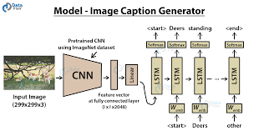

**FIGURE :2**

**RESULT AND DISCUSSION:**

The image caption generation results and discussions demonstrate how well the methodology was applied and how consistently it produced linguistically coherent and semantically relevant captions for a wide range of images. Strict evaluation metrics like ROUGE, CIDEr, METEOR, and BLEU confirm the accuracy and caliber of the generated captions. Notably, the model integrates pre-trained Convolutional Neural Networks (CNNs) for feature extraction and recurrent neural network (RNN) or transformer-based architectures for caption generation, resulting in descriptive and informative captions that capture contextual information and subtle nuances within images. Notwithstanding advancements, handling complicated scenes and unclear objects continues to present difficulties, highlighting the necessity for ongoing research and development to strengthen model robustness and contextual understanding. Emphasizing the promising capabilities of image caption generation systems, the discussions also explore potential applications, ranging from content generation in multimedia platforms to assistive technologies for visually impaired individuals. All things considered, the findings and conversations highlight the methodology's effectiveness while suggesting directions for future development and research in the area.

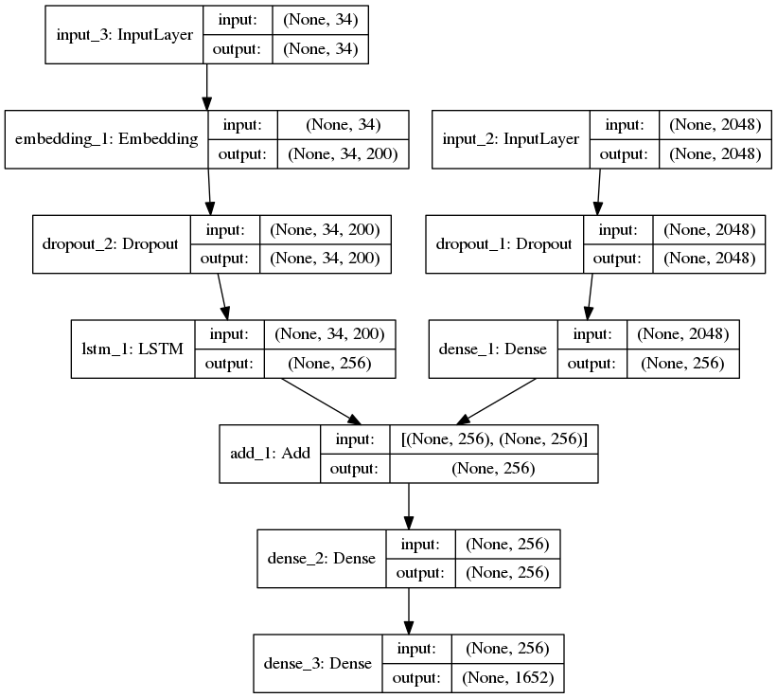

**FIG 3: Workflow Diagram**

**CONCLUSION:**

Though there are many ongoing research projects aiming at more accurate image feature extraction and semantically better sentence generation, automatically captioning images is still far from mature. We used a smaller dataset (Flickr8k) because of limited computational power, but we were still able to accomplish what we had stated in the project proposal. If given more time, there might be improvements. First off, the network does not adjust to this training dataset because we employed a pre-trained CNN network straight into our pipeline without any fine-tuning. We therefore anticipate getting a marginally higher BLEU4 score by experimenting with various CNN pre-trained networks and turning on fine-tuning. Training on a combination of Flickr8k, Flickr30k, and MSCOCO is another possible improvement, the output will be more accurate the more diverse training datasets the network has seen. We can all agree that this project has piqued our interest in using our knowledge of machine learning to the field of computer vision, and we plan to investigate further in the future.

**REFERENCES:**

Vinyl’s, O., Tosha, A., Bengio, S. and Erhan, D., 2015. Show and tell: A neural image caption generator. In *Proceedings of the IEEE conference on computer vision and pattern recognition* (pp. 3156-3164).

Tanti, M., Gattu, A. and Camilleri, K.P., 2018. Where to put the image in an image caption generator. *Natural Language Engineering*, *24*(3), pp.467-489.

Kinghorn, P., Zhang, L. and Shao, L., 2018. A region-based image caption generator with refined descriptions. *Neurocomputing*, *272*, pp.416-424.

Tan, Y.H. and Chan, C.S., 2019. Phrase-based image caption generator with hierarchical LSTM network. *Neurocomputing*, *333*, pp.86-100.

Mathur, P., Gill, A., Yadav, A., Mishra, A. and Bansode, N.K., 2017, June. Camera2Caption: a real-time image caption generator. In *2017 international conference on computational intelligence in data science (ICCIDS)* (pp. 1-6). IEEE.

Sharma, G., Kalena, P., Malde, N., Nair, A. and Parkar, S., 2019, April. Visual image caption generator using deep learning. In *2nd international conference on advances in Science & Technology (ICAST)*.

Panicker, M.J., Upadhayay, V., Sethi, G. and Mathur, V., 2021. Image caption generator. *International Journal of Innovative Technology and Exploring Engineering (IJITEE)*, *10*(3), pp.87-92.

Agrawal, V., Dhekane, S., Tuniya, N. and Vyas, V., 2021, July. Image Caption Generator Using Attention Mechanism. In *2021 12th International Conference on Computing Communication and Networking Technologies (ICCCNT)* (pp. 1-6). IEEE.

Seo, P.H., Sharma, P., Levinboim, T., Han, B. and Soricut, R., 2020, April. Reinforcing an image caption generator using off-line human feedback. In *Proceedings of the AAAI Conference on Artificial Intelligence* (Vol. 34, No. 03, pp. 2693-2700).

Kumar, N.K., Vigneswari, D., Mohan, A., Laxman, K. and Yuvaraj, J., 2019, March. Detection and recognition of objects in image caption generator system: A deep learning approach. In *2019 5th International Conference on Advanced Computing & Communication Systems (ICACCS)* (pp. 107-109). IEEE.

Chen, J., Dong, W. and Li, M., 2014. Image caption generator based on deep neural networks. *ttps://www. math. ucla. edu/minchen/doc/ImgCapGen. pdf*.

Baig, M.M.A., Shah, M.I., Wajahat, M.A., Zafar, N. and Arif, O., 2018, December. Image caption generator with novel object injection. In *2018 Digital Image Computing: Techniques and Applications (DICTA)* (pp. 1-8). IEEE.

Xu, K., Ba, J., Kiros, R., Cho, K., Courville, A., Salakhudinov, R., Zemel, R. and Bengio, Y., 2015, June. Show, attend and tell: Neural image caption generation with visual attention. In *International conference on machine learning* (pp. 2048-2057). PMLR.

Poghosyan, A. and Sarukhanyan, H., 2017, September. Short-term memory with read-only unit in neural image caption generator. In *2017 Computer Science and Information Technologies (CSIT)* (pp. 162-167). IEEE.

Miyazaki, T. and Shimizu, N., 2016, August. Cross-lingual image caption generation. In *Proceedings of the 54th Annual Meeting of the Association for Computational Linguistics (Volume 1: Long Papers)* (pp. 1780-1790).